DBMS ASSIGNMENT 4

1. Customers : Stores customer details.
CREATE TABLE Customers (
customer_id INT PRIMARY KEY,
name VARCHAR(50),
email VARCHAR(100),
city VARCHAR(50),
age INT
);

2. Orders :Stores order details placed by customers.
CREATE TABLE Orders (
order_id INT PRIMARY KEY,
customer_id INT,
order_date DATE,
total_amount DECIMAL(10,2),
status VARCHAR(20),
FOREIGN KEY (customer_id) REFERENCES Customers(customer_id)
);

3. Products : Stores product details.
CREATE TABLE Products (
product_id INT PRIMARY KEY,
name VARCHAR(50),
category VARCHAR(50),
price DECIMAL(10,2),
stock INT
);

4. Order_Items : Stores products included in an order.
CREATE TABLE Order_Items (
order_item_id INT PRIMARY KEY,
order_id INT,
product_id INT,
quantity INT,
subtotal DECIMAL(10,2),
FOREIGN KEY (order_id) REFERENCES Orders(order_id),
FOREIGN KEY (product_id) REFERENCES Products(product_id)
);

Solve following queries :
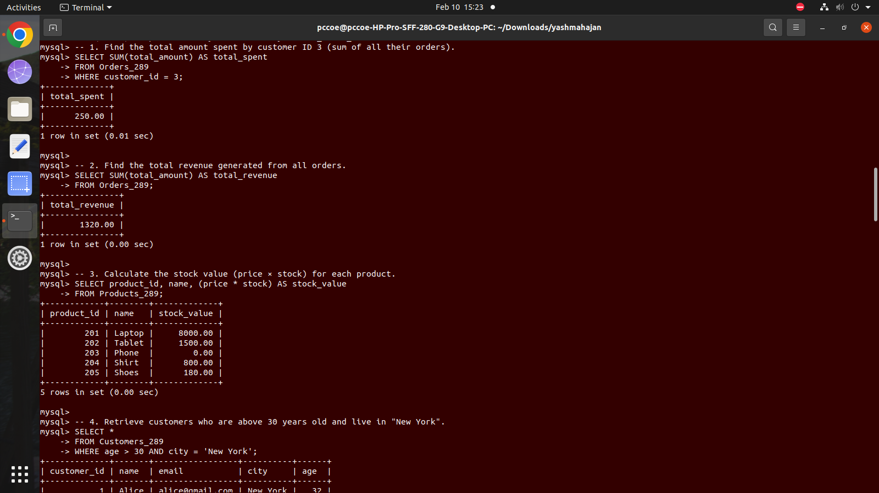
1. Find the total amount spent by customer ID 3 (sum of all their orders).
2. Find the total revenue generated from all orders.


3. Calculate the stock value (price × stock) for each product.


4. Retrieve customers who are above 30 years old and live in "New York".
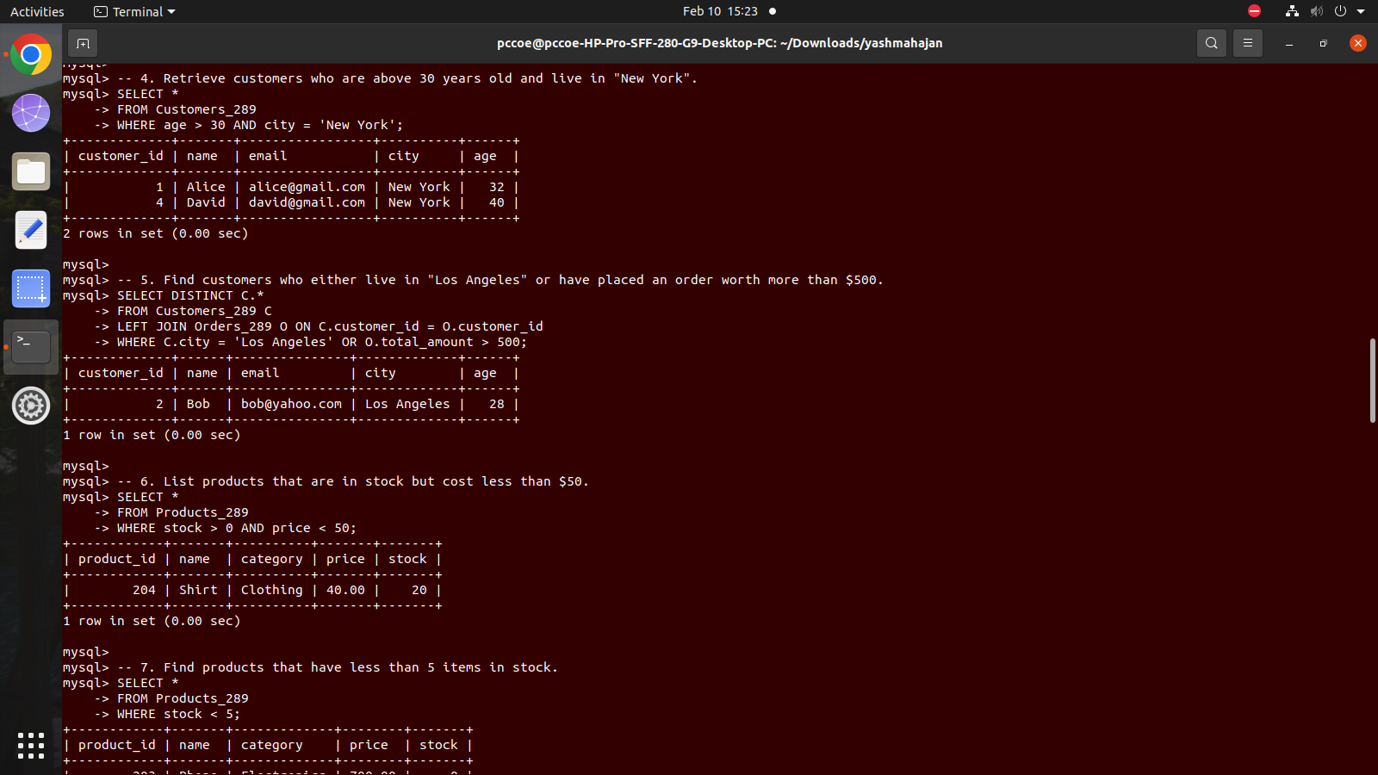

5. Find customers who either live in "Los Angeles" or have placed an order worth more
than $500.

6. List products that are in stock but cost less than $50.


7. Find Products That Have Less Than 5 Items in Stock

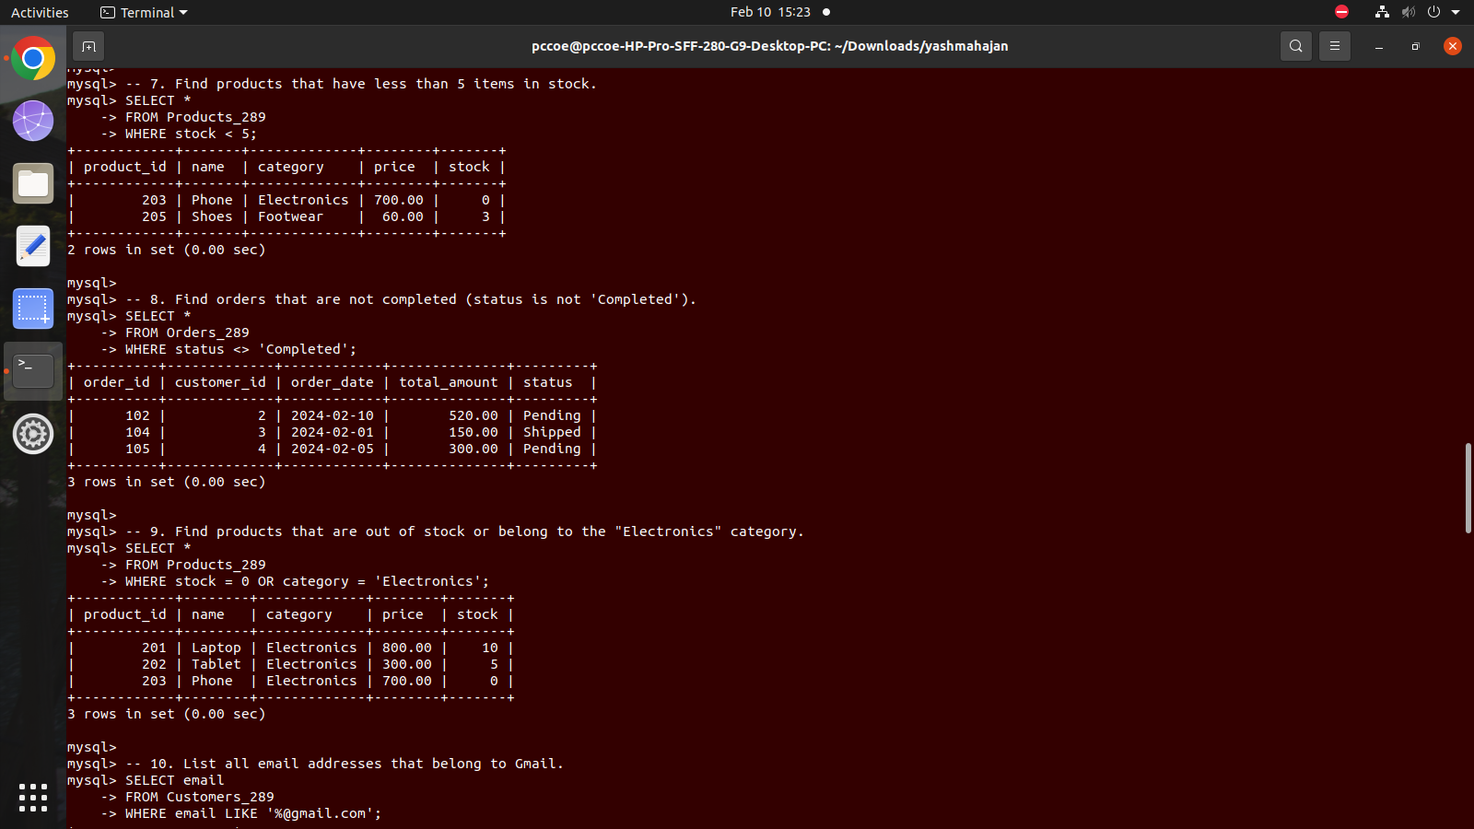

8. Find orders that are not completed (status is not 'Completed').


9. Find products that are out of stock or belong to the "Electronics" category.


10. List all email addresses that belong to Gmail.

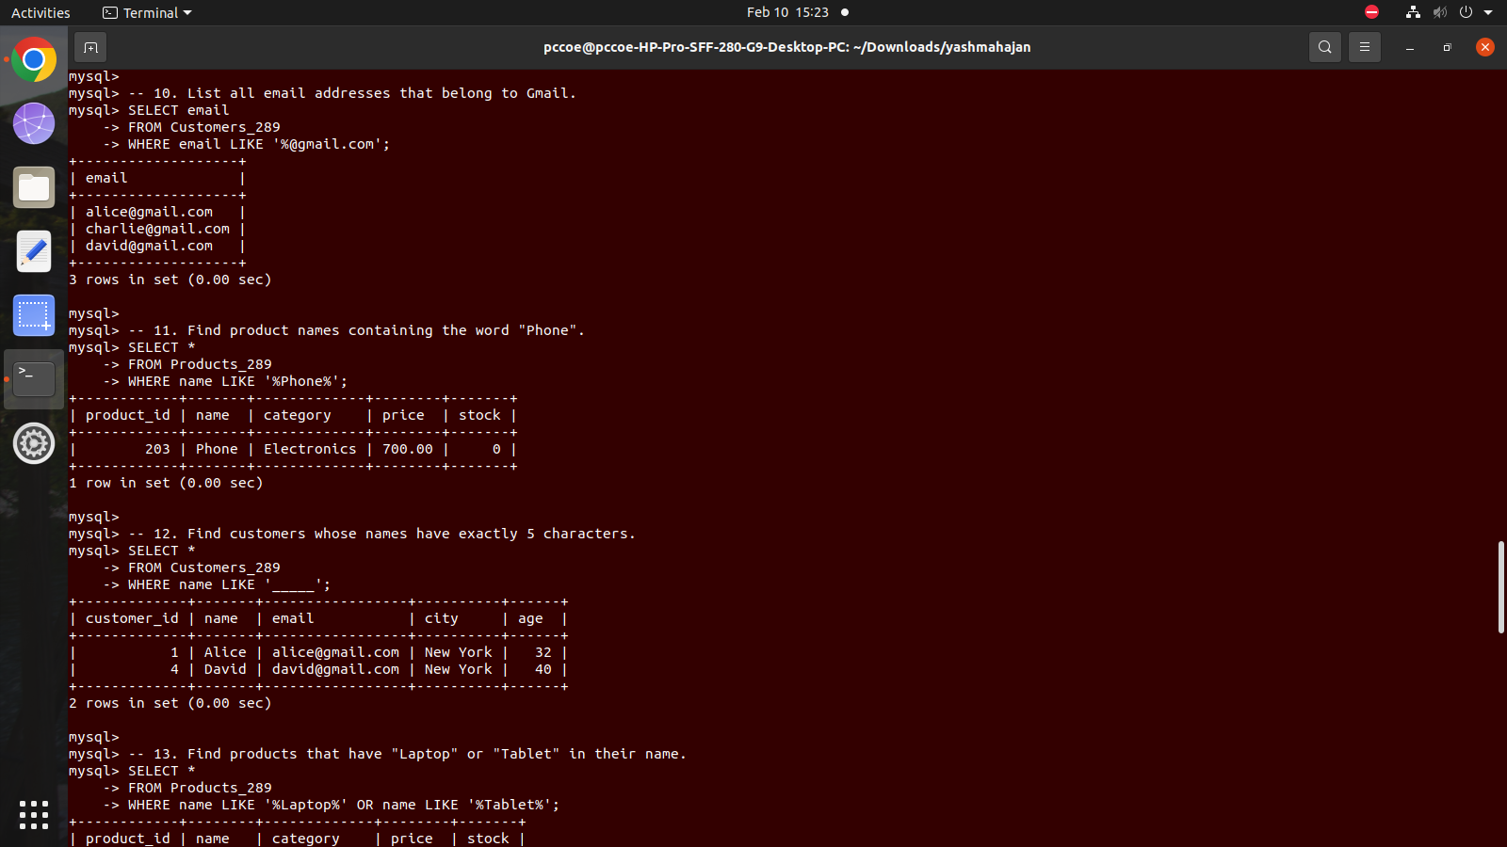

11. Find product names containing the word "Phone".



12. Find customers whose names have exactly 5 characters.


13. Find Products That Have "Laptop" or "Tablet" in Their Name
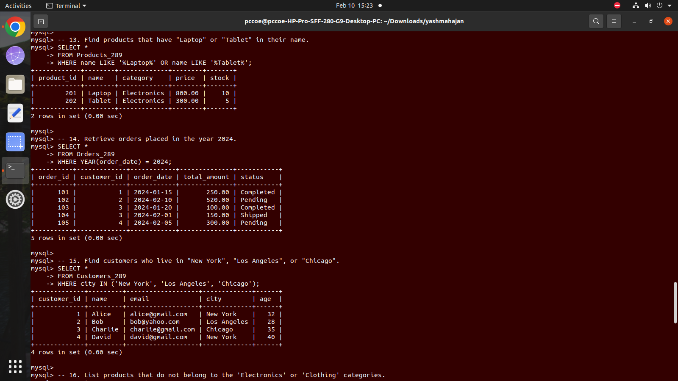

14. Retrieve orders placed in the year 2024.


15. Find customers who live in "New York", "Los Angeles", or "Chicago".



16. List products that do not belong to the 'Electronics' or 'Clothing' categories.
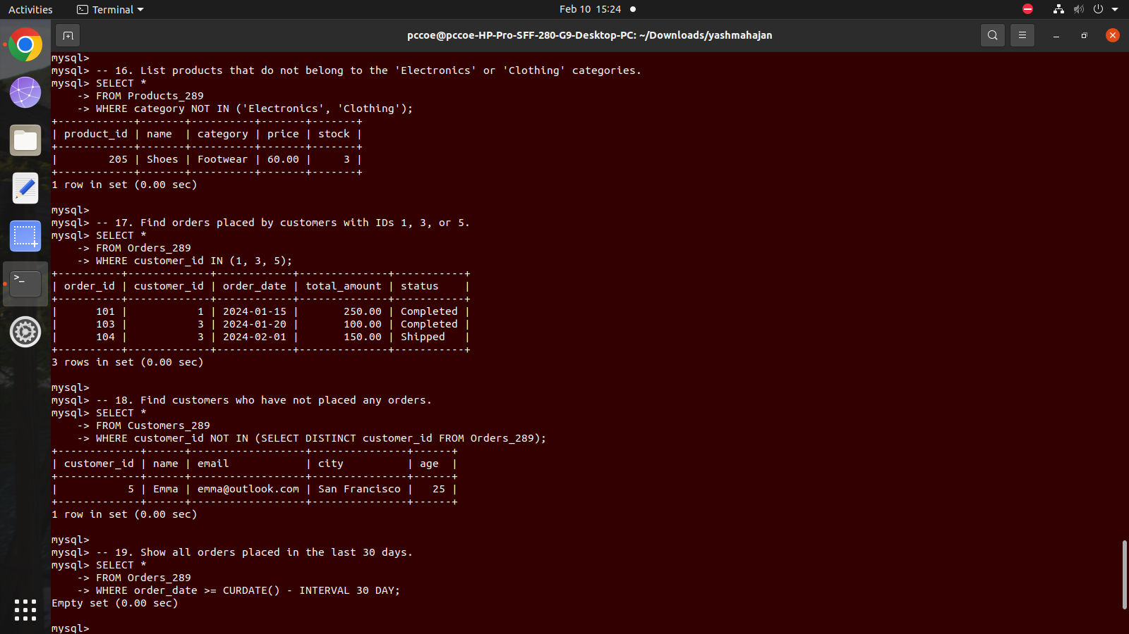

17. Find orders placed by customers with IDs 1, 3, or 5.


18. Find customers who have not placed any orders.


19. Show All Orders Placed in the Last 30 Days



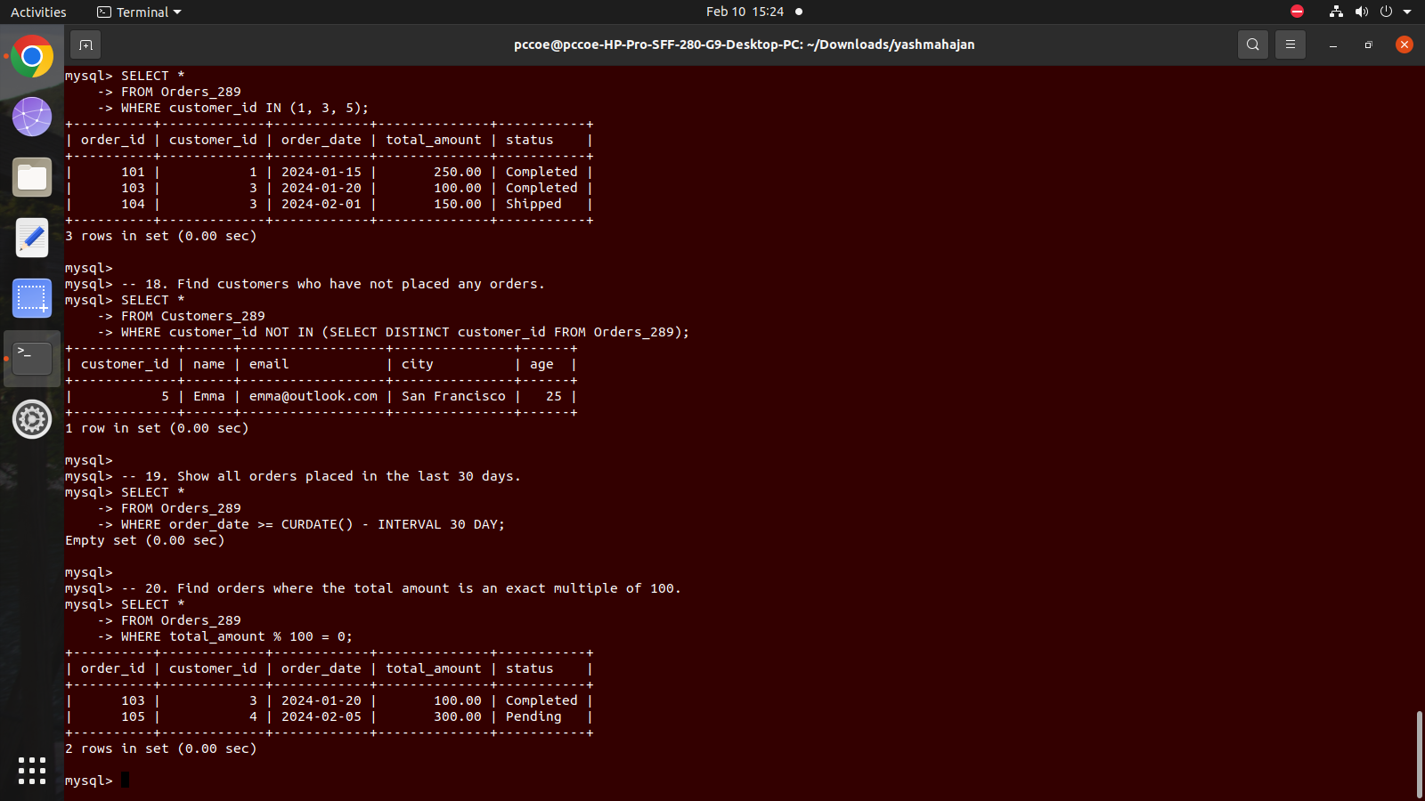
20. Find Orders Where the Total Amount is an Exact Multiple of 100

